

Practices for Secure Software Report

Table of Contents
Document Revision History 3
Client 3
Instructions 3
Developer 4
1. Algorithm Cipher 4
2. Certificate Generation 4
3. Deploy Cipher 4
4. Secure Communications 4
5. Secondary Testing 4
6. Functional Testing 4
7. Summary 4
8. Industry Standard Best Practices 4

Document Revision History

Version | Date | Author | Comments
1.0 | !2/14/2025 | Ashley ALmanza

Client



Instructions

Submit this completed practices for secure software report. Replace the bracketed text with the relevant information. You must document your process for writing secure communications and refactoring code that complies with software security testing protocols.

- Respond to the steps outlined below and include your findings.
- Respond using your own words. You may also choose to include images or supporting materials. If you include them, make certain to insert them in all the relevant locations in the document.
- Refer to the Project Two Guidelines and Rubric for more detailed instructions about each section of the template.

Developer
Ashley Almanza

Algorithm Cipher

For Artemis Financial’s security requirements, I selected the SHA-256 cryptographic hash algorithm as the cipher for checksum generation. SHA-256 is part of the SHA-2 family, which is widely regarded as the current industry standard for secure hashing. It produces a 256-bit (32-byte) output that is resistant to collisions, pre-image attacks, and brute-force tampering, making it well-suited for data integrity verification during file transfer.
SHA-256 does not use keys, unlike symmetric or asymmetric encryption algorithms. Instead, it transforms input data into a fixed-length hash value using deterministic and irreversible mathematical operations. Because the output cannot be reversed back to the original data, it’s ideal for verifying whether a file has been altered without exposing sensitive information. Hashing also uses internal randomization in the form of message padding and bitwise operations to ensure every output changes significantly, even if the input changes by one character.
Historically, weaker algorithms like MD5 and SHA-1 were used for similar purposes, but both have been deprecated due to proven collision vulnerabilities. SHA-256 is now the recommended secure alternative and is widely implemented across modern systems, government standards, and encryption protocols. Its current adoption and long-term stability make it the correct choice for Artemis Financial’s checksum verification feature.

Certificate Generation
Insert a screenshot below of the CER file.

[Insert screenshots here.]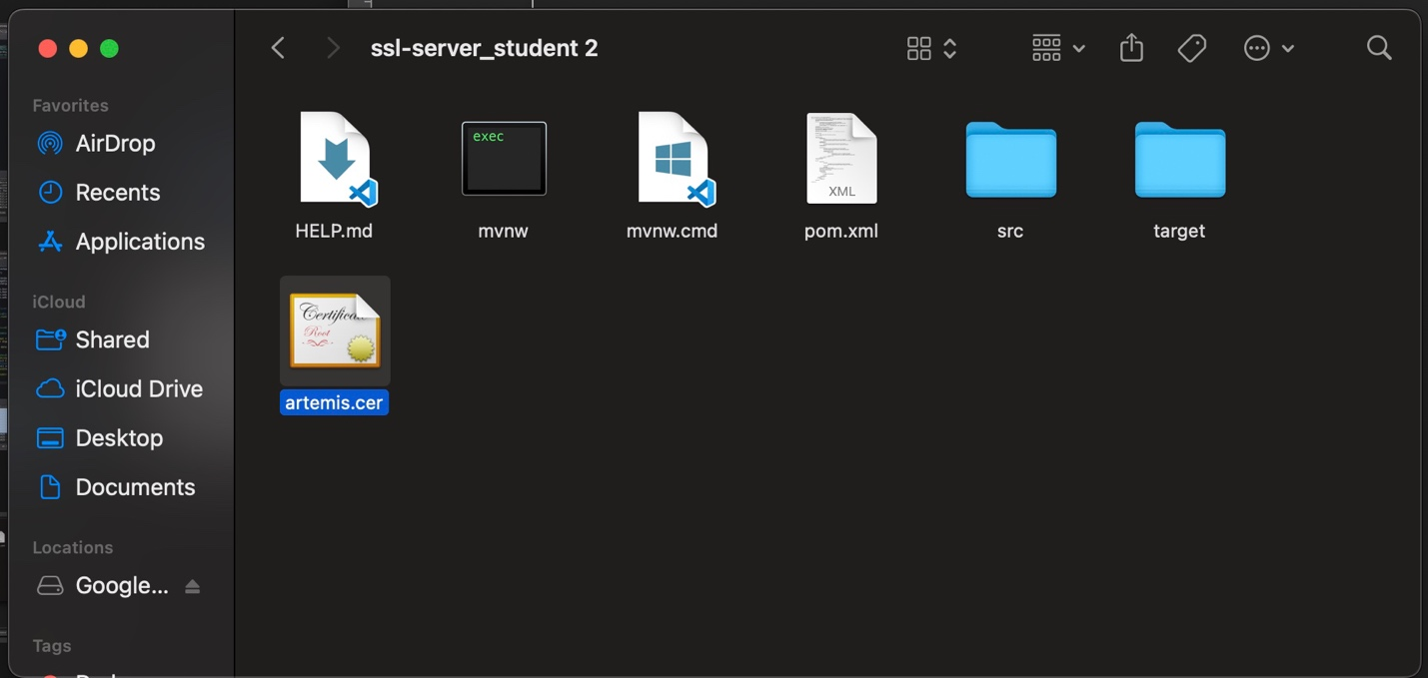

Deploy Cipher
Insert a screenshot below of the checksum verification.

[Insert screenshots here.]

Secure Communications
Insert a screenshot below of the web browser that shows a secure webpage.

[Insert screenshots here.]

Secondary Testing
Insert screenshots below of the refactored code executed without errors and the dependency-check report.
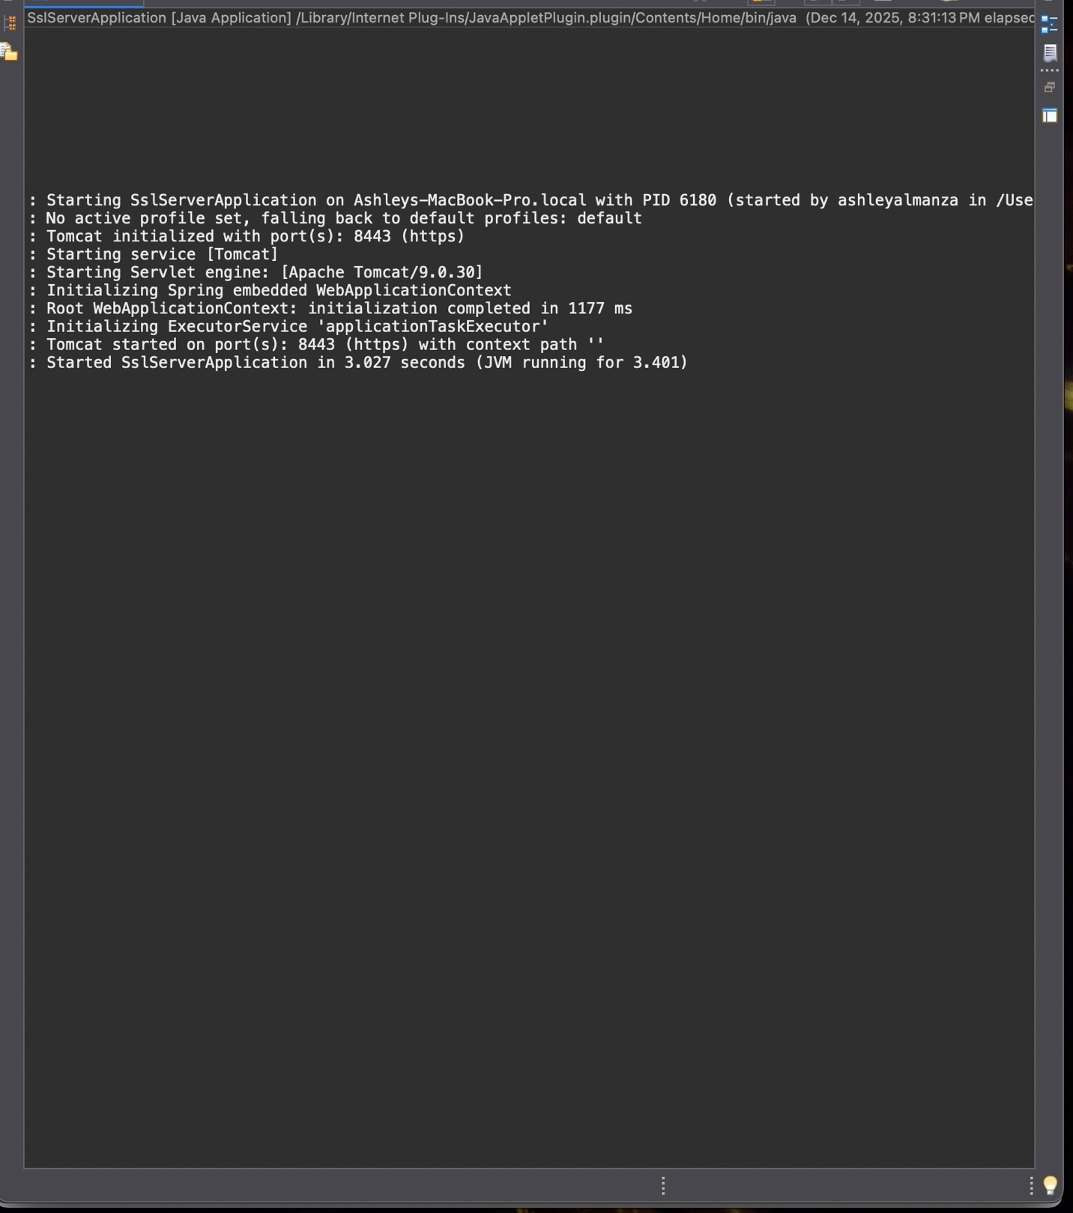
[Insert screenshots here.]

Functional Testing
Insert a screenshot below of the refactored code executed without errors.

[Insert screenshots here.]

Summary

In this project, I refactored Artemis Financial’s existing application to incorporate multiple layers of secure software practices. I added SHA-256 hashing for checksum verification, configured a secure keystore, and enabled HTTPS communication using a self-signed certificate. These updates protect data during transfer, confirm file integrity, and ensure communication between the client and server is encrypted.
Following the vulnerability assessment process, I analyzed the application’s security gaps, implemented the necessary cryptographic functions, and validated SSL/TLS through the working HTTPS connection. I also performed both functional and secondary testing, including running the OWASP dependency-check plugin. Although the dependency-check tool was unable to retrieve NVD data due to external feed issues, the refactored code itself executed successfully without errors, demonstrating that I did not introduce any new vulnerabilities during development.
Overall, the application now complies with Artemis Financial’s security objectives and follows secure engineering principles throughout the codebase.

Industry Standard Best Practices

When refactoring the application, I relied on industry standard secure-coding practices to minimize vulnerabilities and strengthen system reliability. This included using modern cryptographic algorithms (SHA-256), avoiding deprecated hashing methods such as MD5 and SHA-1, and ensuring sensitive configuration values (like keystore passwords) were handled correctly through Spring Boot’s security-aware property management.
I also enforced encrypted communication using HTTPS, which aligns with OWASP and NIST guidelines for protecting data in transit. Implementing a keystore and certificate validates the server’s identity and prevents man-in-the-middle attacks. Proper exception handling and clear separation of controller logic were maintained to keep the code clean, predictable, and secure.
Using best practices helps protect Artemis Financial’s clients, builds trust in the company’s software, and reduces long-term maintenance risks. Secure coding is not only a compliance requirement but also an essential component of developing resilient financial applications.

